INTERNET INTRODUCTION

We are all living in an era of the Internet and might have accessed it for seeking information. You might have searched for your degree results and viewed it from a website. People rely on different websites for various purposes like submitting online applications, viewing web contents, watching movies, banking transactions, purchase of goods through online transactions, and so on. A website is a collection of web pages. A web page may contain texts, graphics, sounds, animations and movies. A website consisting of several web pages are designed to give information about an organization, product, service etc…Web pages are developed with the help of a language called HTML. Html is also known as the language of the Internet, HTML tells the browser how to display the contents on a browser window.
Example of Internet is internet,
How is this website made available on the Internet ?
These web pages are to be stored in web servers connected to the Internet, to be made available to others.

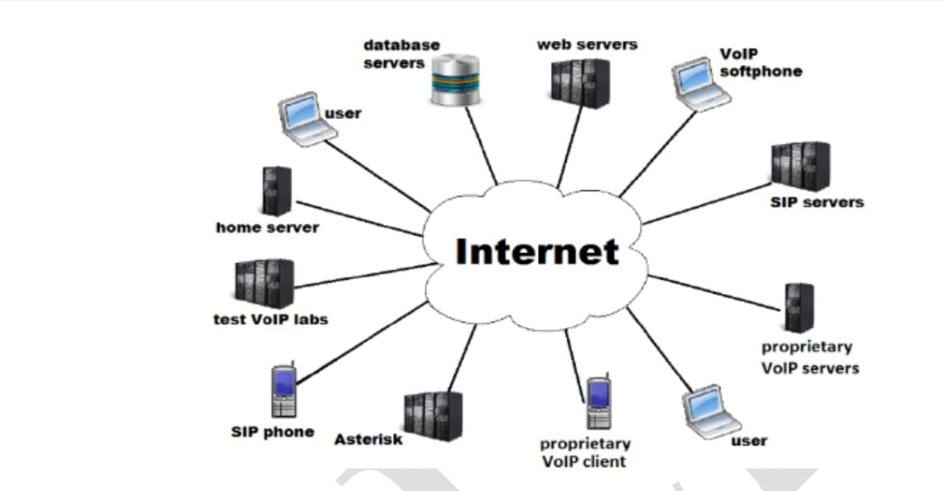

The Internet (or internet) is the global system of interconnected computer networks that uses the Internet protocol suite (TCP/IP) to communicate between networks and devices. It is a network of networks that consists of private, public, academic, business, and government networks of local to global scope, linked by a broad array of electronic, wireless, and optical networking technologies. The Internet carries a vast range of information resources and services, such as the interlinked hypertext documents and applications of the World Wide Web (WWW), electronic mail, telephony, and file sharing. The origins of the Internet date back to the development of packet switching and research commissioned by the United States Department of Defense in the 1960s to enable time-sharing of computers. The primary precursor network, the ARPANET, initially served as a backbone for interconnection of regional academic and military networks in the 1970s. The funding of the National Science Foundation Network as a new backbone in the 1980s, as well as private funding for other commercial extensions, led to worldwide participation in the development of new networking technologies, and the merger of many networks.
The origins of the Internet date back to the development of packet switching and research commissioned by the United States Department of Defense in the 1960s to enable time-sharing of computers. The primary precursor network, the ARPANET, initially served as a backbone for interconnection of regional academic and military networks in the 1970s. The funding of the National Science Foundation Network as a new backbone in the 1980s, as well as private funding for other commercial extensions, led to worldwide participation in the development of new networking technologies, and the merger of many networks.
The linking of commercial networks and enterprises by the early 1990s marked the beginning of the transition to the modern Internet, and generated a sustained exponential growth as generations of institutional, personal, and mobile computers were connected to the network. Although the Internet was widely used by academia in the 1980s, commercialization incorporated its services and technologies into virtually every aspect of modern life. Most traditional communication media, including telephony, radio, television, paper mail and newspapers are reshaped, redefined, or even bypassed by the Internet, giving birth to new services such as email, Internet telephony, Internet television, online music, digital newspapers, and video streaming websites. Newspaper, book, and other print publishing are adapting to website technology, or are reshaped into blogging, web feeds and online news aggregators. The Internet has enabled and accelerated new forms of personal interactions through instant messaging, Internet forums, and social networking services. Online shopping has grown exponentially for major retailers, small businesses, and entrepreneurs, as it enables firms to extend their "brick and mortar" presence to serve a larger market or even sell goods and services entirely online. Business-to-business and financial services on the Internet affect supply chains across entire industries. The Internet has no single centralized governance in either technological implementation or policies for access and usage; each constituent network sets its own policies. The overreaching definitions of the two principal name spaces in the Internet, the Internet Protocol address (IP address) space and the Domain Name System (DNS), are directed by a maintainer organization, the Internet Corporation for Assigned Names and Numbers (ICANN). The technical underpinning and standardization of the core protocols is an activity of the Internet Engineering Task Force (IETF), a non-profit organization of loosely affiliated international participants that anyone may associate with by contributing technical expertise. In November 2006, the Internet was included on USA Today's list of New Seven Wonders.

WWW
The World Wide Web (WWW), commonly known as the Web, is an information system where documents and other web resources are identified by Uniform Resource Locators (URLs, such as https://example.com/), which may be interlinked by hyperlinks, and are accessible over the Internet. The resources of the Web are transferred via the Hypertext Transfer Protocol (HTTP), may be accessed by users by a software application called a web browser, and are published by a software application called a web server. The World Wide Web is not synonymous with the Internet, which pre-dated the Web in some form by over two decades and upon which technologies the Web is built. English scientist Sir Timothy Berners-Lee invented the World Wide Web in 1989. He wrote the first web browser in 1990 while employed at CERN near Geneva, Switzerland. The browser was released outside CERN to other research institutions starting in January 1991, and then to the general public in August 1991. The Web began to enter everyday use in 1993-4, when websites for general use started to become available. The World Wide Web has been central to the development of the Information Age, and is the primary tool billions of people use to interact on the Internet. Web resources may be any type of downloaded media, but web pages are hypertext documents formatted in Hypertext Markup Language (HTML). Special HTML syntax displays embedded hyperlinks with URLs which permits users to navigate to other web resources. In addition to text, web pages may contain references to images, video, audio, and software components which are either displayed or internally executed in the user's web browser to render pages or streams of multimedia content. Multiple web resources with a common theme and usually a common domain name, make up a website. Websites are stored in computers that are running a web server, which is a program that responds to requests made over the Internet from web browsers running on a user's computer. Website content can be provided by a publisher, or interactively from user generated content. Websites are provided for a myriad of informative, entertainment, commercial, and governmental reasons.

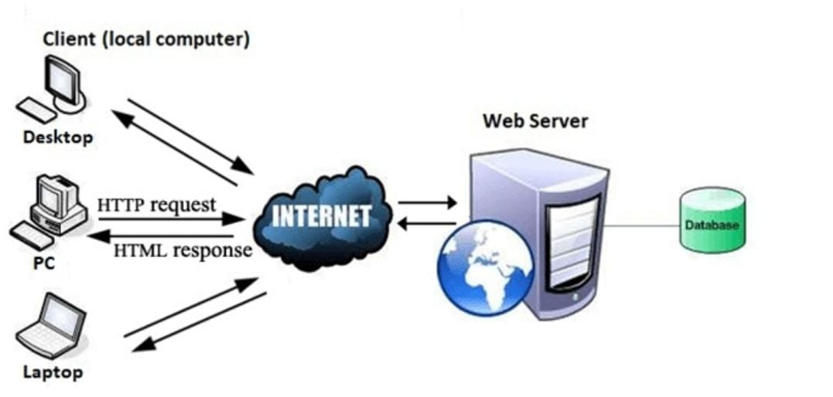

WHAT IS THE DIFFERENCE BETWEEN THE INTERNET AND THE WEB ?
The internet is infrastructure while the web is service on top of that infrastructure.
(Real life example : internet is like roads / web is like different transportation system which utilises road)
Internet and Web is not the same thing: Web uses internet to pass over the information.

UNDERSTANDING CLIENT/SERVER ROLE
Client–server model is a distributed application structure that partitions tasks or workloads between the providers of a resource or service, called servers, and service requesters, called clients. Often clients and servers communicate over a computer network on separate hardware, but both client and server may reside in the same system. A server host runs one or more server programs, which share their resources with clients. A client usually does not share any of its resources, but it requests content or service from a server. Clients, therefore, initiate communication sessions with servers, which await incoming requests. Examples of computer applications that use the client–server model are email, network printing, and the World Wide Web.

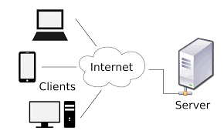

WEB BROWSER
A web browser (commonly referred to as a browser) is application software for accessing the World Wide Web. When a user requests a web page from a particular website, the web browser retrieves the necessary content from a web server and then displays the page on the user's device.
A web browser is not the same thing as a search engine, though the two are often confused. A search engine is a website that provides links to other websites. However, to connect to a website's server and display its web pages, a user must have a web browser installed. Web browsers are used on a range of devices, including desktops, laptops, tablets, and smartphones. In 2020, an estimated 4.9 billion people used a browser. The most used browser is Google Chrome, with a 63% global market share on all devices, followed by Safari with 19%. Other notable browsers include Firefox and Microsoft Edge.
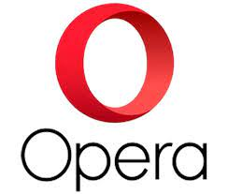

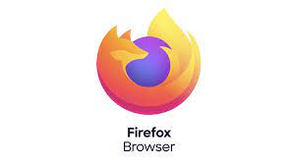

Web server technologies
Let us see what happens internally when we visit the website www.bvmcollege.com, the website of the College.
At first, the home page (the first page displayed when a website will be accessed) of the website will be transferred to our computer (client) from the web server of these college. The client is usually a computer or a mobile device which has a browser software that requests for web pages. The web server uses the web server software to store the pages of the websites and delivers it on request from the client.

WEB SERVER
The term web server is often used for referring to the server computer that hosts websites. It is also used to refer to a web server software that is installed in a server computer in order to make it a web server.
A web server enables us to deliver web pages or services like e-mail, blog, etc to users on the Internet. A web server consists of a server computer that runs a server operating system and a web server software installed on it for providing services like www, e-mail, etc. over the Internet.
A web server is a powerful computer which is always switched on and connected to high bandwidth Internet connection. This will facilitate Internet users around the world to access the websites and services hosted by it at any point of time. Depending on the requirements, a web server can have single or multiple processors, fast access RAM, high performance hard disk, Ethernet cards that supports fast communication etc. To ensure faster Internet connectivity and redundant power supply, a web server is usually installed in a data center.
A web server is computer software and underlying hardware that accepts requests via HTTP, the network protocol created to distribute web pages, or its secure variant HTTPS. A user agent, commonly a web browser or web crawler, initiates communication by making a request for a specific resource using HTTP, and the server responds with the content of that resource or an error message. The server can also accept and store resources sent from the user agent if configured to do so. A server can be a single computer, or even an embedded system such as a router with a built in configuration interface, but high traffic websites typically run web servers on fleets of computers designed to handle large numbers of requests for documents, multimedia files and interactive scripts. A resource sent from a web server can be a pre existing file available to the server, or it can be generated at the time of the request by another program that communicates with the server program. The former is often faster and more easily cached for repeated requests, while the latter supports a broader range of applications. Websites that serve generated content usually incorporate stored files whenever possible. Technologies such as REST and SOAP, which use HTTP as a basis for general computer-to-computer communication, have extended the application of web servers well beyond their original purpose of serving human-readable pages.

